SHOWER

**Extro Plastic Sink Tap with Swivel Spout – Product Description**  
Upgrade your kitchen or bathroom with the Extro Plastic Sink Tap featuring a high-arc, 360° swivel spout for enhanced accessibility and water control. Crafted from durable plastic with a smooth finish, this wall-mounted tap is easy to install and ideal for both domestic and utility spaces. Its ergonomic lever handle ensures effortless operation, while the rust-proof design guarantees long-term use in wet environments.

**Key Features:**  
✅ 360° rotating gooseneck spout for easy movement  
✅ Durable, lightweight plastic construction  
✅ Ergonomic single-lever handle for smooth operation  
✅ Rust-proof and corrosion-resistant body  
✅ Wall flange included for neat and secure installation

**Product Specifications**  
**Brand:** Extro  
**Product Type:** Plastic Sink Tap with Swivel Spout  
**Material:** Premium Quality Plastic  
**Finish:** White & Yellow  
**Handle Type:** Single Lever  
**Spout Type:** 360° Swivel Gooseneck  
**Mounting Type:** Wall Mount  
**Thread Size:** 15 mm (½ inch BSP)  
**Wall Flange:** Included  
**Application:** Kitchen sinks, utility basins, bathroom wash areas  
**Warranty:** Typically 1 year (verify with dealer)

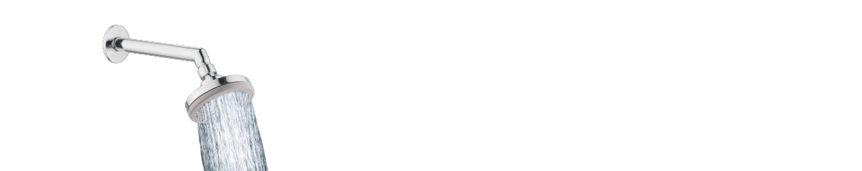

**Extro Overhead Square Rain Shower Head – Chrome Finish**

**Product Description:**  
Transform your daily shower into a luxurious rainfall experience with the Extro Overhead Square Rain Shower Head. Crafted from high-quality stainless steel and polished with a mirror-like chrome finish, this sleek and durable shower head delivers consistent water flow through evenly distributed nozzles, providing a spa-like soak every time.

**5 Key Features (in single line):**  
✅ Wide square design for full-body coverage  
✅ Anti-clog silicone nozzles for easy cleaning  
✅ High-grade stainless steel with chrome finish  
✅ Universal connection with swivel ball joint  
✅ Rust- and corrosion-resistant build

**Product Specifications**  
**Brand:** Extro  
**Product Type:** Overhead Rain Shower Head  
**Material:** Stainless Steel  
**Finish:** Polished Chrome  
**Shape:** Square  
**Size:** Typically 8" x 8" or 10" x 10" (verify with actual model)  
**Nozzle Type:** Anti-clog silicone  
**Connection Type:** ½ inch BSP (universal)  
**Mount Type:** Ceiling or wall-arm compatible  
**Swivel Ball Joint:** Yes, for angle adjustment  
**Application:** Bathroom overhead shower setup  
**Warranty:** Typically 1–3 years (verify with dealer)

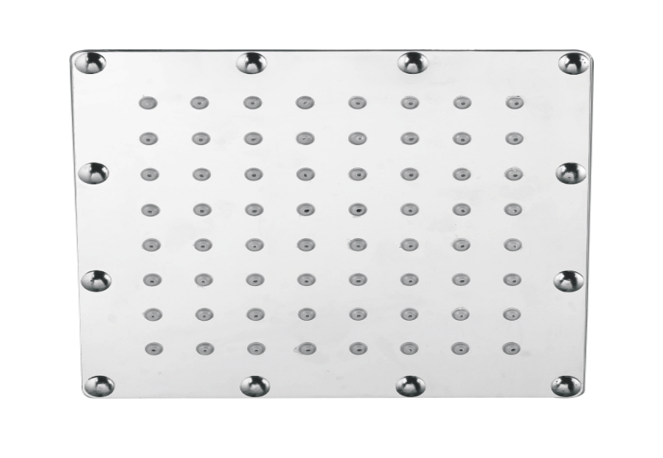

**Extro Wall-Mount Round Overhead Shower with Arm – Chrome Finish**

**Product Description:**  
Enjoy a refreshing shower with the Extro Wall-Mount Round Overhead Shower. Featuring a compact yet powerful spray head and a sturdy chrome-finished body, this shower head offers consistent water flow and simple installation. Ideal for modern bathrooms, it comes with a swivel ball joint and a wall-mount arm for optimal positioning and user convenience.

**5 Key Features (in single line):**  
✅ Compact round design for focused water flow  
✅ Anti-clog nozzles for easy maintenance  
✅ Chrome-plated brass arm with swivel adjustment  
✅ Rust- and corrosion-resistant build  
✅ Quick wall-mount installation with standard fittings

**Product Specifications**  
**Brand:** Extro  
**Product Type:** Round Wall-Mount Overhead Shower  
**Material:** ABS body with brass arm  
**Finish:** Polished Chrome  
**Shower Head Shape:** Round  
**Nozzle Type:** Soft silicone anti-clog  
**Connection Size:** ½ inch BSP standard  
**Swivel Ball Joint:** Yes, for angle adjustment  
**Mounting Type:** Wall-mount with flange  
**Application:** Bathroom overhead shower setup  
**Warranty:** Typically 1–3 years (verify with dealer)

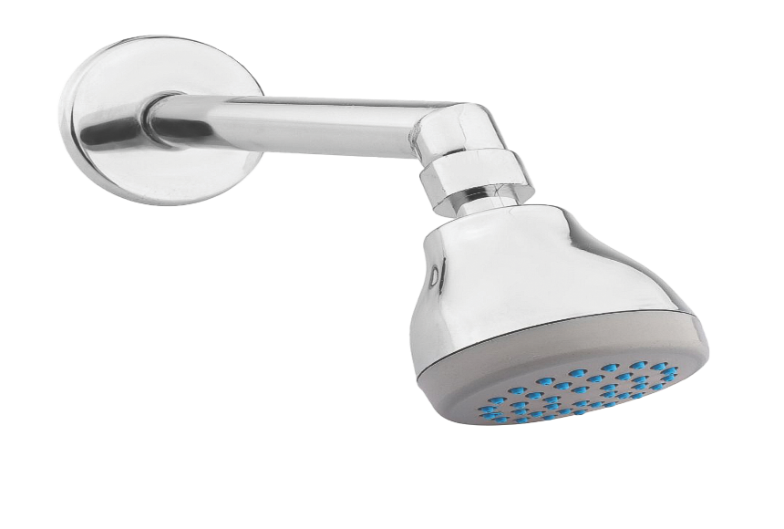

**Extro Wall-Mount Slim Round Overhead Shower**

**Product Description:**  
Experience a smooth and rejuvenating shower with the Extro Slim Round Overhead Shower. Its sleek profile and uniform spray pattern offer an elegant addition to any bathroom setup.

**5 Key Features (in single line):**  
✅ Slim design with even water distribution  
✅ Chrome-plated body for lasting shine  
✅ Easy angle adjustment with swivel joint  
✅ Compatible with all standard wall shower arms  
✅ Corrosion-resistant and easy to maintain

**Product Specifications**

* **Brand:** Extro
* **Product Type:** Overhead Shower Head
* **Material:** ABS with chrome plating
* **Shape:** Slim round
* **Finish:** Polished Chrome
* **Mounting:** Wall-mount with arm
* **Connection Size:** ½ inch BSP
* **Swivel Joint:** Yes
* **Warranty:** 1–2 years (verify with dealer)

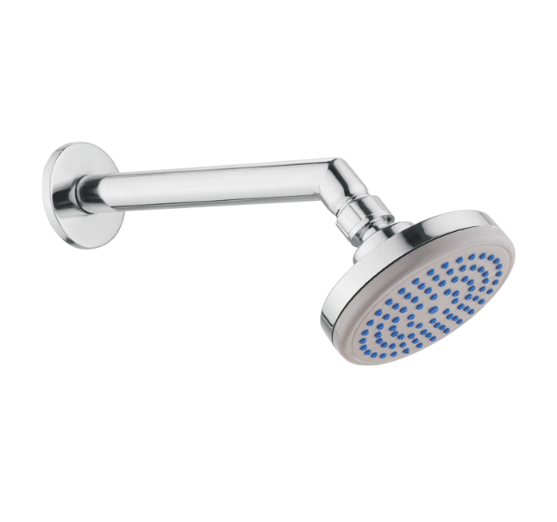

**Extro Round Multi-Flow Hand Shower – Chrome**

**Product Description:**  
The Extro Round Multi-Flow Hand Shower brings spa-like comfort to your bathroom. With multiple spray settings, it delivers personalized water flow for a relaxing experience.

**5 Key Features (in single line):**  
✅ Multiple spray modes for varied showering  
✅ Easy-clean nozzles with anti-clog design  
✅ Chrome-plated finish for modern appeal  
✅ Universal connection for easy installation  
✅ Comes with wall-mounted holder

**Product Specifications**

* **Brand:** Extro
* **Product Type:** Hand Shower
* **Material:** ABS Body
* **Finish:** Chrome
* **Spray Modes:** Multi-function
* **Mount Type:** Wall holder with hook
* **Connection Size:** ½ inch BSP
* **Application:** Bathroom handheld shower
* **Warranty:** 1 year

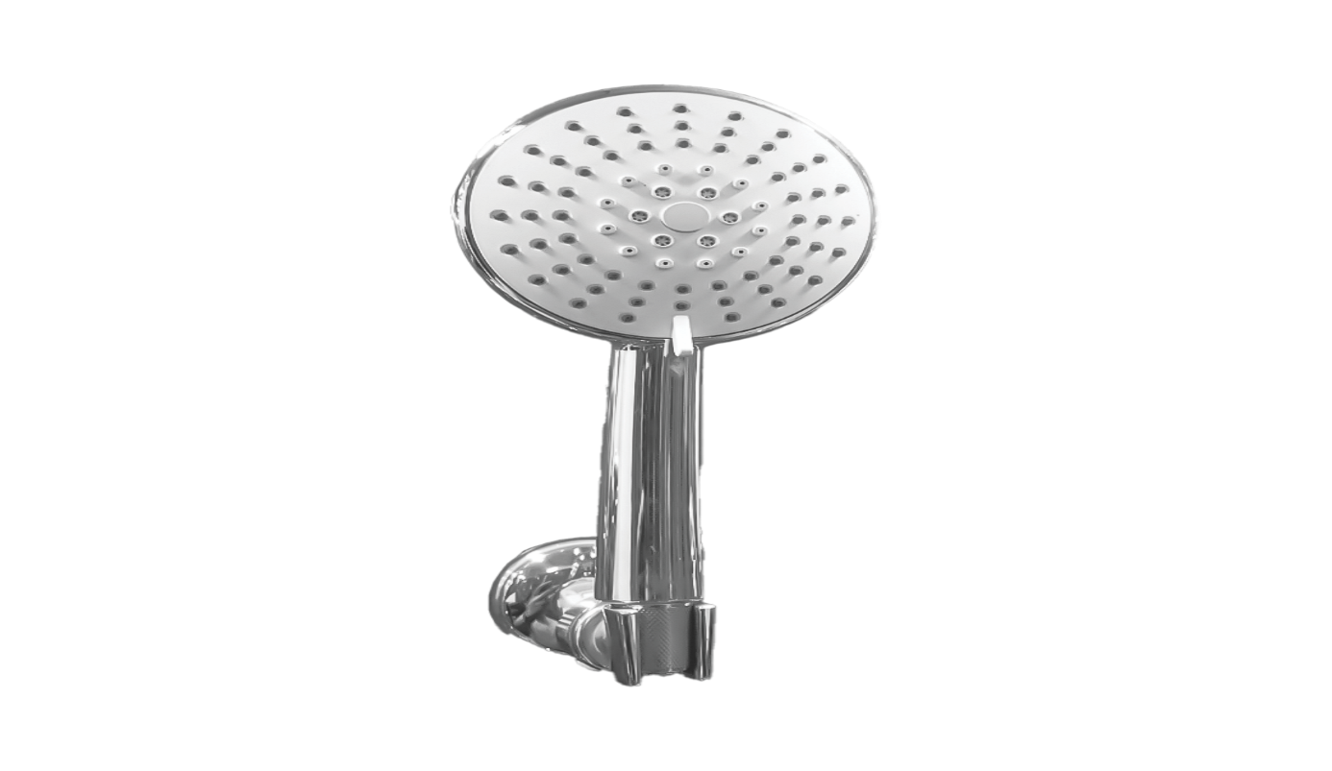

**Extro Matte Black Hand Shower**

**Product Description:**  
Designed for contemporary bathrooms, the Extro Matte Black Hand Shower combines functionality with bold aesthetics. It offers a wide spray area for effective rinsing.

**5 Key Features (in single line):**  
✅ Stylish matte black finish for premium look  
✅ Wide coverage spray with soft nozzles  
✅ Ergonomic handle for easy grip  
✅ Compatible with standard shower hoses  
✅ Durable and easy to clean

**Product Specifications**

* **Brand:** Extro
* **Product Type:** Hand Shower
* **Material:** ABS
* **Finish:** Matte Black
* **Connection Size:** ½ inch BSP
* **Application:** Bathroom handheld shower
* **Warranty:** 1 year

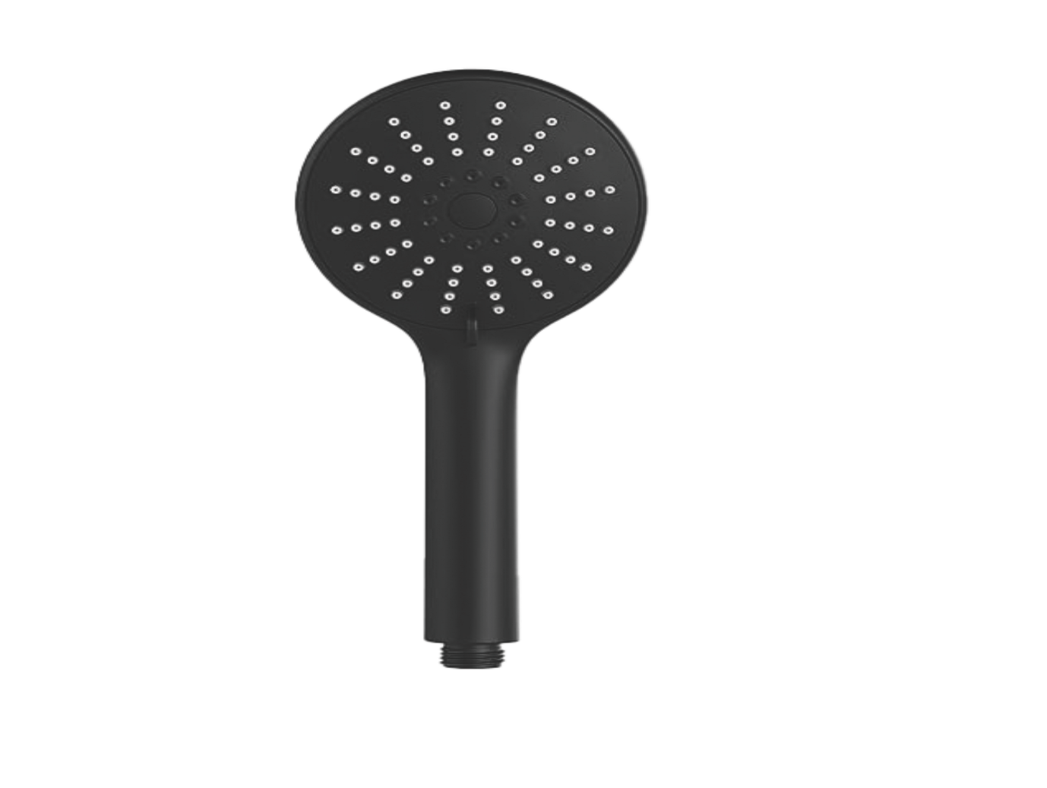

**Extro Flexible Shower Hose – Matte Black**

**Product Description:**  
The Extro Matte Black Shower Hose offers excellent flexibility and durability, making it a perfect fit for hand showers. Designed to resist tangling and kinking, it ensures smooth water flow.

**5 Key Features (in single line):**  
✅ High-flexibility design prevents kinks  
✅ Matte black finish for modern bathrooms  
✅ Leak-proof threaded ends  
✅ Rust- and corrosion-resistant build  
✅ Compatible with all ½ inch fittings

**Product Specifications**

* **Brand:** Extro
* **Product Type:** Shower Hose
* **Material:** High-quality PVC or stainless steel with matte black coating
* **Length:** Typically 1.5 meters (confirm variant)
* **Connection Size:** ½ inch BSP (both ends)
* **Finish:** Matte Black
* **Warranty:** 1 year

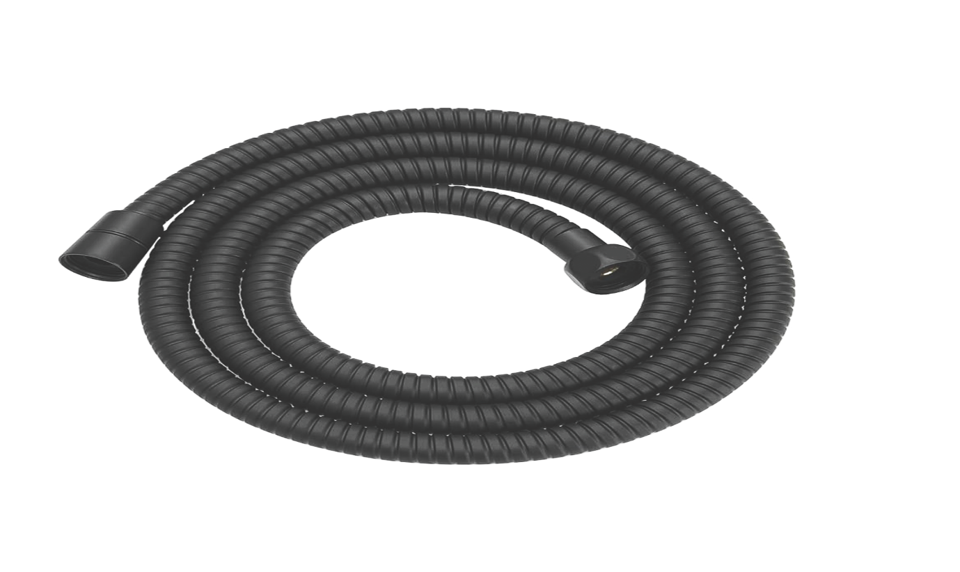

**Extro Premium Health Faucet – Chrome**

**Product Description:**  
The Extro Premium Health Faucet is designed for hygiene and ease of use. Its ergonomic design ensures precise control and powerful jet spray for personal cleaning.

**5 Key Features (in single line):**  
✅ Smooth trigger operation for water control  
✅ Sleek chrome finish for a polished look  
✅ Durable ABS construction  
✅ Universal nozzle fit  
✅ Ideal for toilet and bathroom hygiene

**Product Specifications**

* **Brand:** Extro
* **Product Type:** Health Faucet
* **Material:** ABS Body
* **Finish:** Chrome
* **Trigger Type:** Single press
* **Connection Size:** ½ inch BSP
* **Usage:** Toilet/Bathroom hygiene
* **Warranty:** 1 year

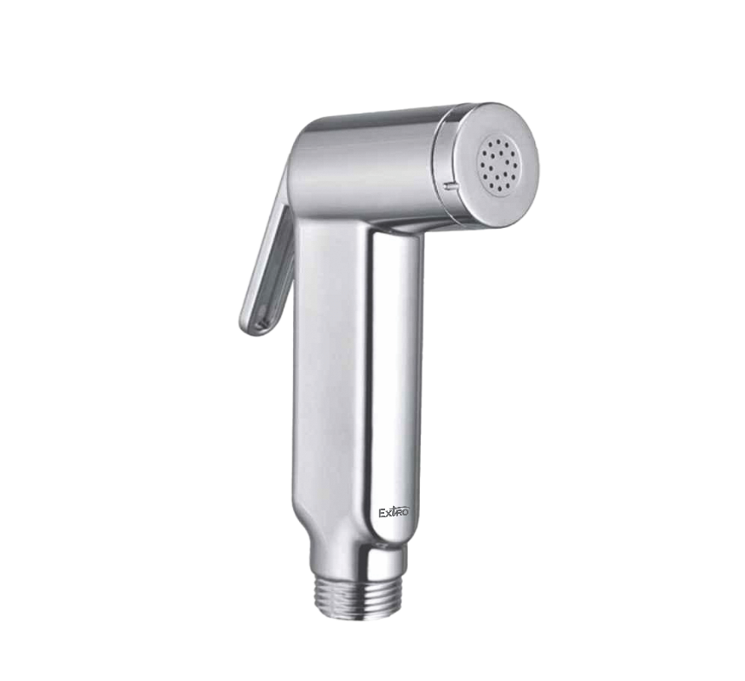

**Extro Soft-Jet Health Faucet – Chrome with Soft Blue Accents**

**Product Description:**  
The Extro Soft-Jet Health Faucet combines modern style with gentle water spray. Ideal for personal hygiene, it features a soft-touch control and sleek design.

**5 Key Features (in single line):**  
✅ Soft water jet for gentle use  
✅ Blue-accented head for a stylish contrast  
✅ Rust-resistant chrome-plated ABS  
✅ Comfortable grip and trigger  
✅ Universal connection with easy installation

**Product Specifications**

* **Brand:** Extro
* **Product Type:** Health Faucet
* **Material:** ABS
* **Finish:** Chrome with blue accents
* **Trigger Type:** Soft press
* **Connection Size:** ½ inch BSP
* **Warranty:** 1 year

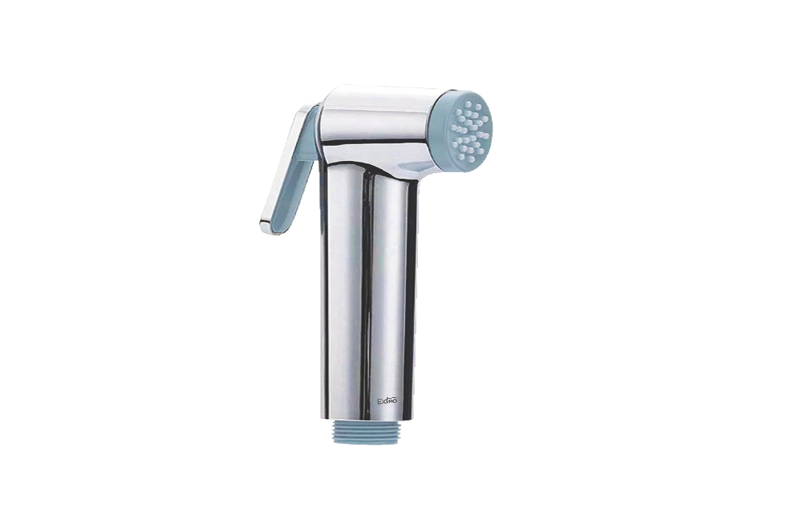

**Extro Aqua-Jet Health Faucet – Sleek Chrome Body with Beige Accents**

**Product Description:**  
The Extro Aqua-Jet Health Faucet delivers a powerful yet controlled spray, designed for hygiene and ease of use with a premium chrome finish and soft-touch beige nozzle.

**5 Key Features (in single line):**  
✅ Strong and consistent water jet  
✅ Elegant chrome-plated ABS body  
✅ Ergonomic trigger with soft press control  
✅ Easy to clean and maintain  
✅ Standard ½ inch universal thread

**Product Specifications:**  
• Brand: Extro  
• Product Type: Health Faucet  
• Material: ABS Plastic  
• Finish: Chrome with beige nozzle and trigger  
• Connection Size: ½ inch BSP  
• Trigger Type: Soft press lever  
• Warranty: 1 Year

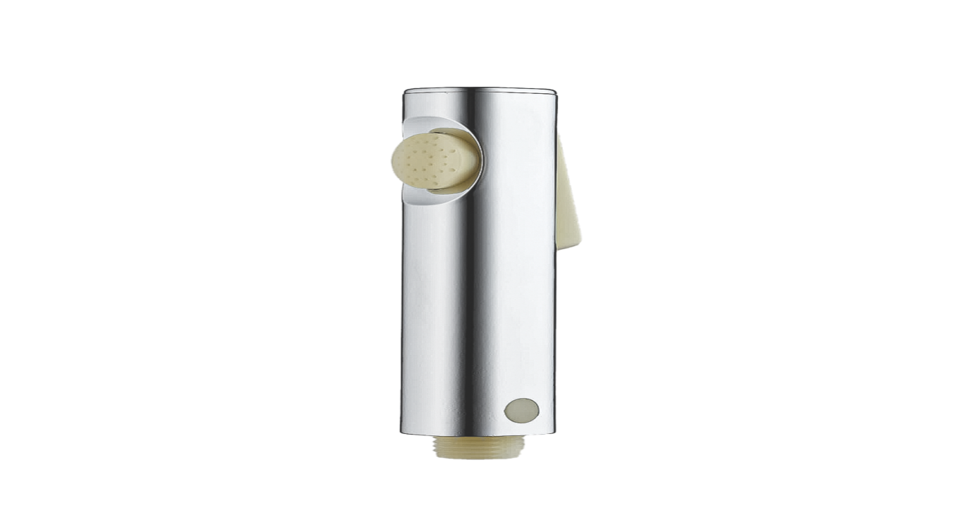

**Extro Stainless Steel Shower Tube – 1.5 Meter**

**Product Description:**  
The Extro Stainless Steel Shower Tube is a flexible, corrosion-resistant pipe that offers a secure connection between your faucet and hand shower or bidet sprayer.

**5 Key Features (in single line):**  
✅ Rust-proof stainless steel build  
✅ Flexible and kink-free movement  
✅ High-pressure endurance  
✅ Universal ½ inch BSP connectors  
✅ Leak-proof threaded ends with rubber seals

**Product Specifications:**  
• Brand: Extro  
• Product Type: Shower Tube / Hose  
• Material: Stainless Steel  
• Length: 1.5 Meter  
• Connector Size: ½ inch BSP  
• Finish: Chrome Polish  
• Warranty: 1 Year

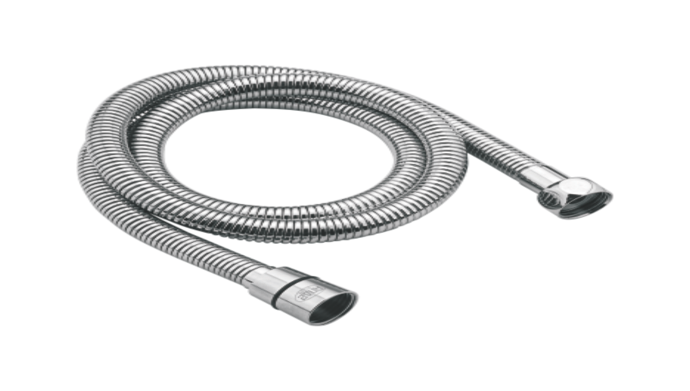

**Extro Round Overhead Shower with Arm – Chrome Finish**

**Product Description:**  
The Extro Round Overhead Shower with wall-mounted arm provides a wide, relaxing water spread for a spa-like bathing experience, made from durable ABS and chrome-plated for elegance.

**5 Key Features (in single line):**  
✅ Wide rain shower spray  
✅ Adjustable shower angle  
✅ Chrome-plated anti-rust body  
✅ Soft silicone nozzles for easy cleaning  
✅ Includes sturdy wall-mounted arm

**Product Specifications:**  
• Brand: Extro  
• Product Type: Overhead Shower with Arm  
• Material: ABS & Stainless Steel  
• Finish: Chrome  
• Arm Length: Approx. 12 Inches  
• Installation: Wall Mounted  
• Warranty: 1 Year

